MEDITATION
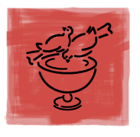

Have you ever wondered – what is Christian meditation… is it prayer…or a mindfulness practice…where does it come from… how to do it…?
Meditation is an important practice in all the great spiritual traditions.

In Christian meditation we seek to go beyond the tumult of our thoughts and feelings and open ourselves to the Spirit of God who dwells in our hearts and in silence is loving to all.

Members of the Christian meditation community locally are offering an introductory course, six consecutive Thursdays at 8 p.m., starting 14th January. Meetings last one hour - at xxxxx, address, postcode.

Add in directions to find the venue if necessary.

For more info. or to register, call xxxx on phone number xxx or email xxxxxx@xxx.com

For general information, see www.christianmeditation.org.uk

We welcome people from any tradition or none.

