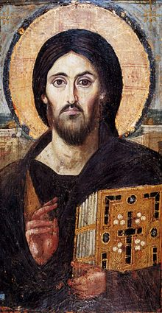
The World Community for Christian Meditation
six week introductory course
Tuesdays 7pm
Starting 18th March 2014

St Theosevia Centre for Spirituality
2 Canterbury Road Oxford OX2 6LU

Meditation is a universal spiritual wisdom and a practice that we find at the core of all the great religious traditions, leading from the mind to the heart. It is a way of simplicity, silence and stillness. It can be practiced by anyone from wherever you are on your life's journey. It is only necessary to be clear about the practice and then to begin - and keep on beginning.

Tuesday 18th March: | What is meditation?
Tuesday 25th March: | John Main
Tuesday 1st April: | The Roots of our Tradition
Tuesday 8th April: | The Wheel of Prayer
Tuesday 15th April: | Leaving Self Behind
Tuesday 29th April: | The Fruits of Meditation
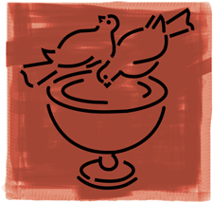
Timings from 7 - 8.15pm approx - £3 per session suggested donation
Further information email Jacqueline Russell on jacq.russell@ntlworld.com
Ph: 07443 946055
www.christianmeditation.org.uk
The Christian Meditation Trust (UK) reg charity no 1101900

